C:\Documents and Settings\scarpenter\Local Settings\Temporary Internet Files\Content.IE5\X9HZ9P5G\MC900058078[1].wmf

Tusculum FRC

Where we are better together

Issue # 9

Sarah Carpenter

Portable 17, 333-5179 x150

<http://tusculumfrc.yolasite.com/>

**What can *you* do?**

* Toys for Tots pick up is December 22nd. Consider donating new toys for the families. Also, consider coming to pass out hot chocolate and toys that day. Donations of blankets and coats (new or used), and hot chocolate and candy canes are also welcome.
* Come spend time with us during one of our classes and get to know our beautiful families!

Sharing Stories

We have a woman who comes regularly for crocheting. She speaks NO English at all. I was able to teach her to crochet, but, most days, she crochets in silence. Monday, a woman, who shared her language, came for our potluck, and our quiet friend told us about her life as a refugee and a survivor. I am so thankful she comes and so thankful she had a chance to share her memories.

Everyone has a story, and the FRC gives families a chance to tell theirs!

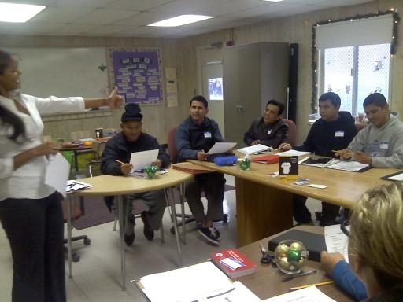

Dominique and Emily are very proud of their Citizenship Class students!

# Friendship is born at that moment when one person says to another: "What! You too?

# I thought I was the only one.”

# ~CS Lewis~



**Special Report**

**The Partner Celebration is December 11th. If you have not yet RSVP’d, please do so by no later than Friday.**

**Teachers, you have until Friday to send me your wishes.**

Thank you to:

My volunteers: Bianca, Ningyu, Wenjing, Shuzhan, Emily, Emily (yes, there are two), Carol, Shannon, Dominique, Lydia, Ray, and Corrine. You make my day!