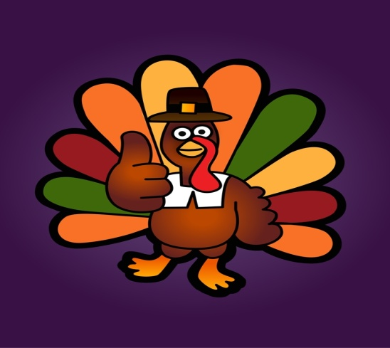

Tusculum FRC

Where we are better together

Issue # 8

Thanksgiving issue: 2 pages

THANKSGIVING EDITION

Because Thanksgiving is next week, this newsletter will be particularly long to cover both weeks.

Thank you to:

**Everyone who came to the Parent Advisory Council.** It was a great time. I’m really excited about all our ideas!

**Nicole Hill, Big Brothers Big Sisters,** for partnering with me. We have paired 9 high school girls with 9 of our kids to build both social and academic skills.

**Emily Ramer** for giving us her limited free time every day to do some intensive classroom help!

**Mr. Joe White (Grandfather) and Ms. Emily White (Mother)** for bringing me a bookcase for the portable. They are donating other furniture to help make it more comfortable for parents.

**United Way of Middle Tennessee** for holding a community Baby Shower and donating 15 bags of supplies for new mothers.

**Everyone** who put on the Family Game Night last night. Lucy had a great time!!

From your Director

You know, there are many days that I go home exhausted. I’m sure you do too. Most of us work in jobs that, though we love them, are busy and complicated and ask a lot of us.

I love Thanksgiving because it really does remind me to stop and be thankful. I’m thankful for a great team of partners and co-workers and volunteers. I’m thankful for the friendships my families are building. I’m thankful for crumbling barriers.

The other night, something that would have been miraculous just 40 years ago, happened—we had round table discussion with men and women of various ages, cultures, and skin tones.

I hope you’re taking time to see the beauty around you and be thankful. I know I forget sometimes.

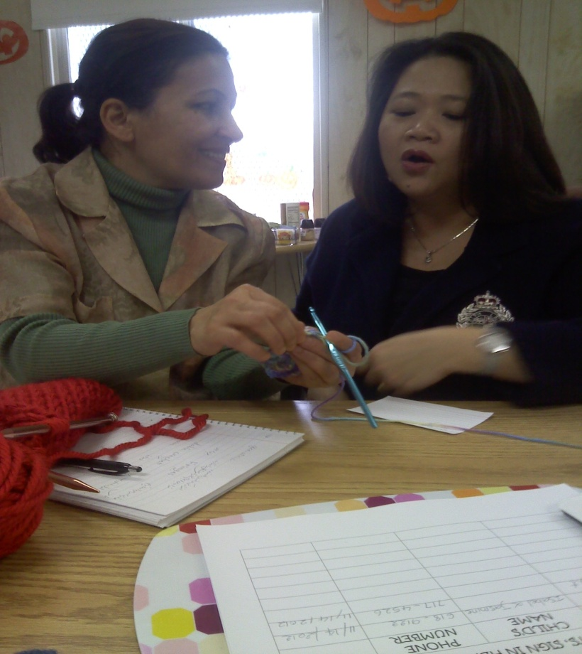

What’s Happening out here?

Citizenship classes have started. We had 10-12 Nepali men and women here for two hours learning how to answer questions about themselves in English.

*TOYS FOR TOTS SIGN UP IS OVER*.

We cannot take any other families. If the family is in need, they can go to the last minute toy store. More information is coming. If you can, please donate new toys so we can make sure every needy family is served.

Despite culture and language barriers, Tien (Vietnam) and Mehrdokht (Iran) become friends during crocheting class.

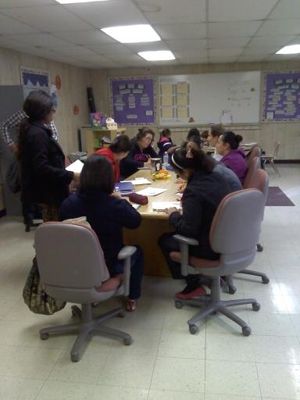

MONDAY ESL CLASS WITH BIANCA

How can you help?

I need volunteers to help with Toys for Tots. Donate new toys to give away or come pass out hot chocolate and blankets for parents who are standing in line outside in the December cold.

Asking for help is very humbling and providing hot chocolate and blankets is a great way to honor parents.

“If the only prayer you said was thank you,

that would be enough.”   
― [Meister Eckhart](http://www.goodreads.com/author/show/73092.Meister_Eckhart)

How this helps Tusculum…

The Parent Advisory Council met the other night, bringing together teachers, parents, and grandparents to discuss the schools strengths and needs. We came up with GREAT ideas and are really excited about seeing how the school will grow as we learn to work together!

**Special Report**

Teachers- I need your wish lists ASAP. We have people who want to help. I don’t know what you need. Please send them before break.

If you don’t know what to include, I have examples.

Sarah Carpenter, Portable 17, x150

[Sarah.carpenter@mnps.org](mailto:Sarah.carpenter@mnps.org)

<http://tusculumfrc.yolasite.com/>