C:\Documents and Settings\scarpenter\Local Settings\Temporary Internet Files\Content.IE5\X9HZ9P5G\MC900058078[1].wmf

Tusculum FRC

Where we are better together

Issue # 7

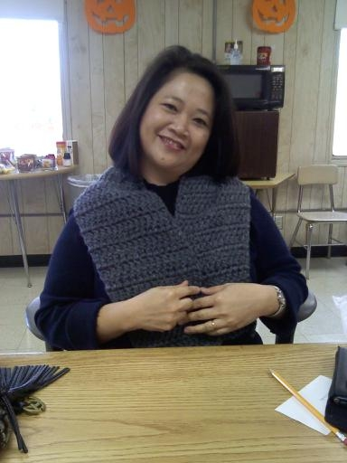

What can *you* do?

Start sending me your wish lists!

My volunteers and I want to start putting them together so we are ready for the partner celebration.

What’s Happening out here?

We had a record 8 people at ESL the other day. We are out of space now. That’s a good problem, isn’t it? ☺

I’ve started signing up families for Toys for Tots. The parents who come to my office are so thankful. They are embarrassed by their need and I have a great chance to show mercy. It’s a good reminder of the power of a kind word.

How does this help Tusculum?

We’ve got tutors in classrooms. Big Brother/Big Sister mentors are going to start coming to meet with kids. I’m helping parents learn how to help their kids with homework.

It’s very encouraging to see what has happened in just two months. I’m confident that we will soon see changes for the better in our kids.

“Hope is the thing with feathers   
That perches in the soul   
And sings the tune without the words   
And never stops at all.”   
― [Emily Dickinson](http://www.goodreads.com/author/show/7440.Emily_Dickinson)

Sarah Carpenter, Portable 17, x150

[Sarah.carpenter@mnps.org](mailto:Sarah.carpenter@mnps.org)

<http://tusculumfrc.yolasite.com/>

Parent Tien Lai learned how to crochet and made 2 scarves in one week! She’s so proud!

**Special Report**

The first Parent Advisory Board is next week. If you have not yet suggested a parent representative for your class, please do so *today*. Many classes are not represented yet by a teacher or a parent. Questions? Ask away!!

Thank you to:

The ladies of Hillcrest United Methodist Church for inviting me to speak to their group. They are very excited to find ways to support our work here!