C:\Documents and Settings\scarpenter\Local Settings\Temporary Internet Files\Content.IE5\X9HZ9P5G\MC900058078[1].wmf

*You don’t [work with the poor]; you share your life with the poor.*

*~Sr. Elaine Roulette~*

What can *you* do?

* Donate yarn, crochet hooks, and knitting needles for the craft group.
* Find me a volunteer to teach our Citizenship Test Prep Class.
* Volunteer whenever you have time.
* Refer me to your community contacts. *This is the most important way you can help me!*

Contact:

Sarah Carpenter, Portable 17, x150

[Sarah.carpenter@mnps.org](mailto:Sarah.carpenter@mnps.org)

<http://tusculumfrc.yolasite.com/>

**Special Report**

Parents will have the chance to come to after school homework and sight word help with their children. At dismissal, I will escort them from school to the portable **ONLY** with signed permission form. Please tell me if you have questions or ideas or want to help. Details coming soon!

What am I doing for Tusculum?

* Volunteer Training Class

Oct 20th

* Parent Group

starts Oct 16th.

* Beginner English class

starts Oct 22nd

* After school sight word and homework help also

starts Oct 22nd

* Crocheting and Knitting group starts Oct 24th
* Intermediate English class

starts Oct 25th

Thank you to:

Heidi from the Belmont Student Tennessee Education Association (STEA). We got $100 in yarn for the craft group! 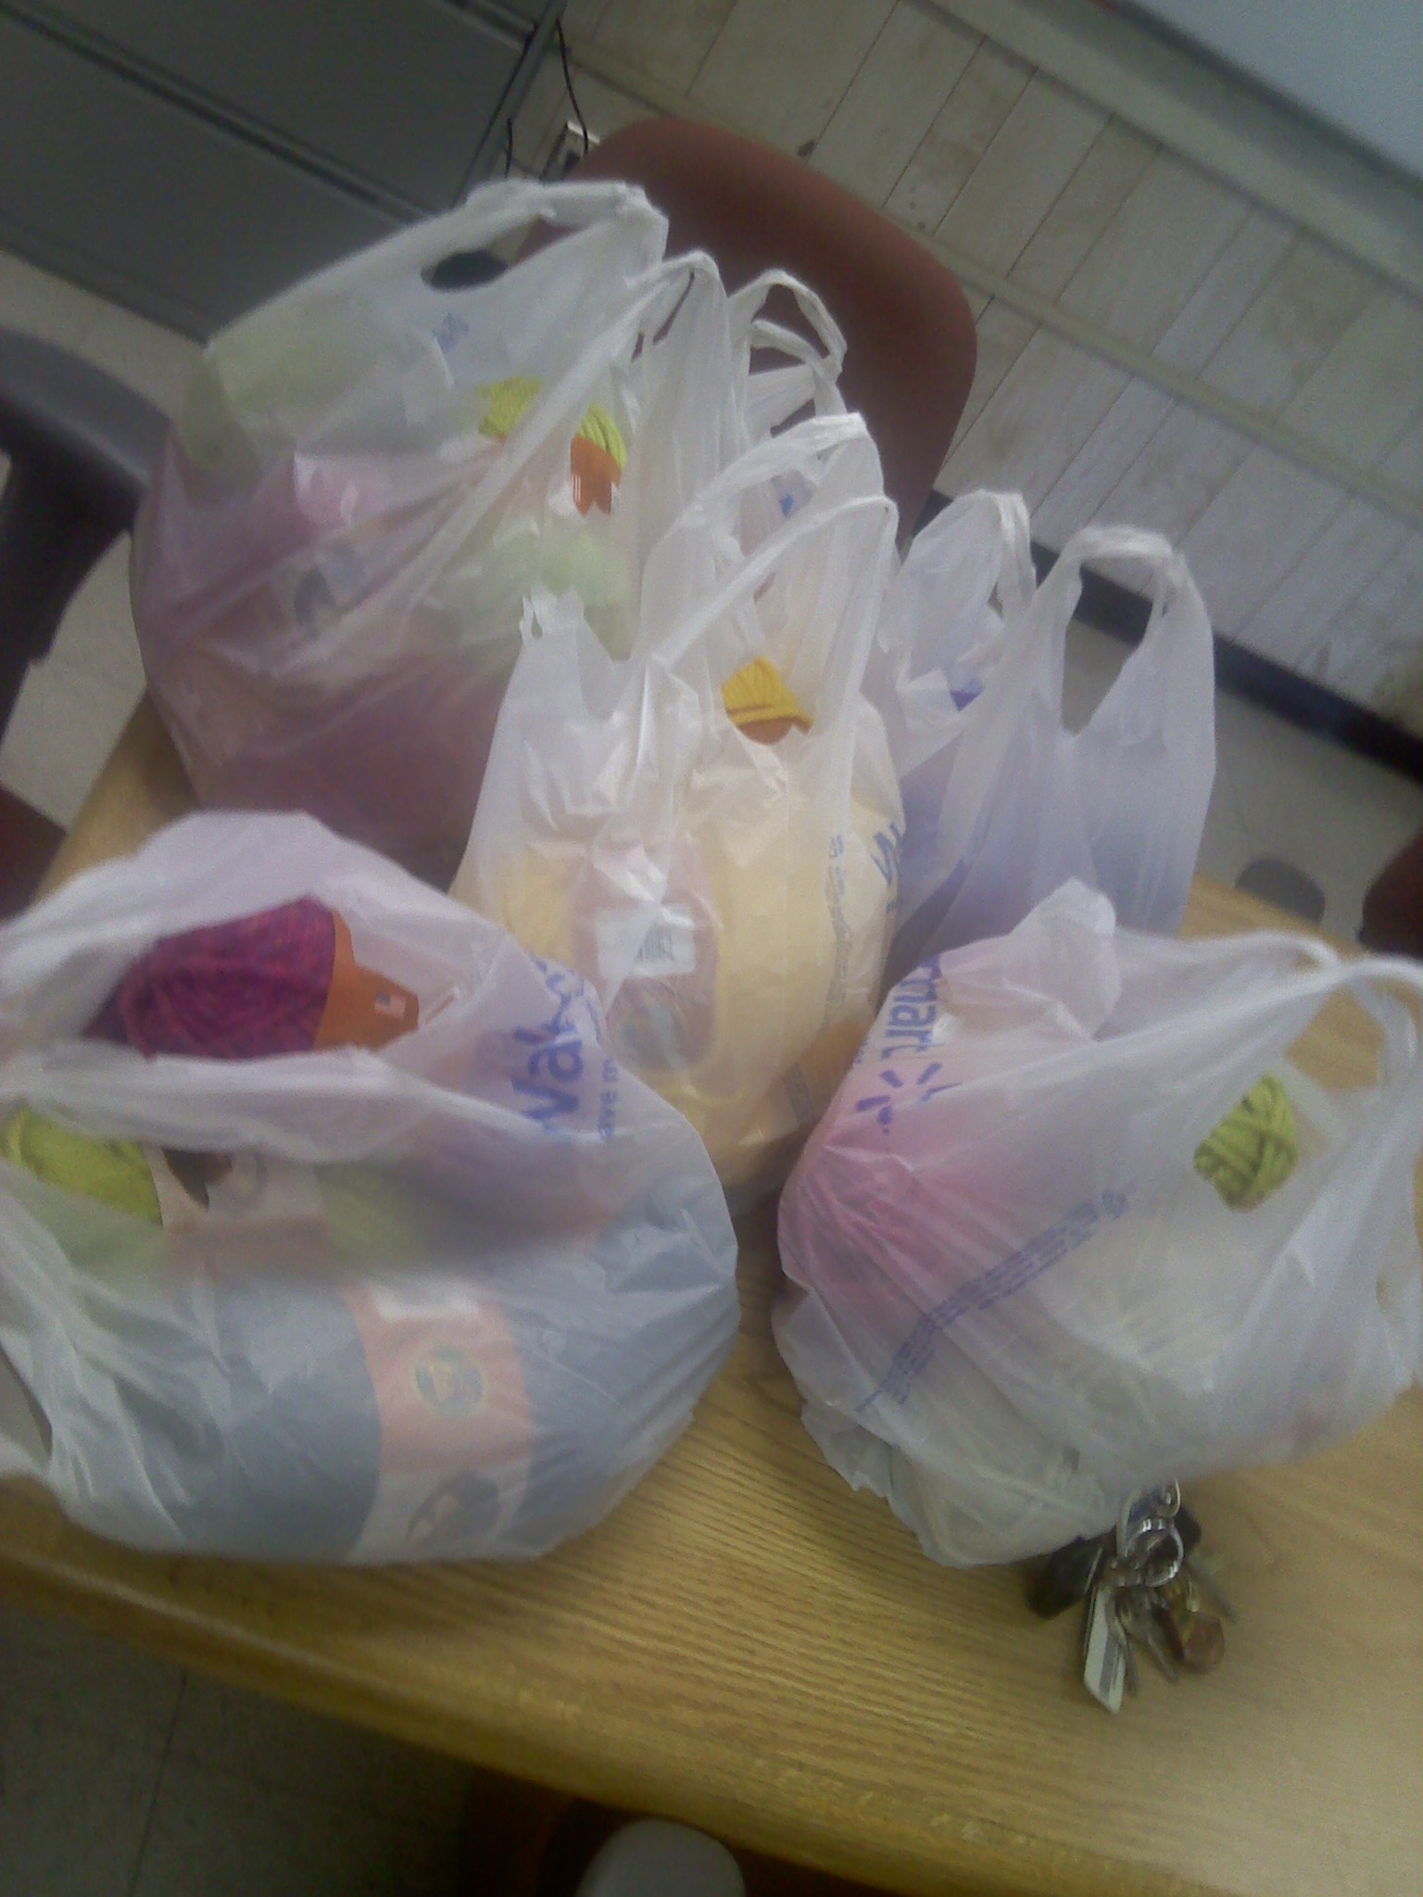

What’s Happening out here?

It’s been a quiet week thanks to fall break. I’ve had time to edit and update the website, create a volunteer guide, and enter a lot of data. It’s kind of nice but I’m looking forward to kids and teachers returning!

Tusculum FRC

Where we are better together

Issue # 4