C:\Documents and Settings\scarpenter\Local Settings\Temporary Internet Files\Content.IE5\X9HZ9P5G\MC900058078[1].wmf

Tusculum FRC

Where we are better together

Issue # 18

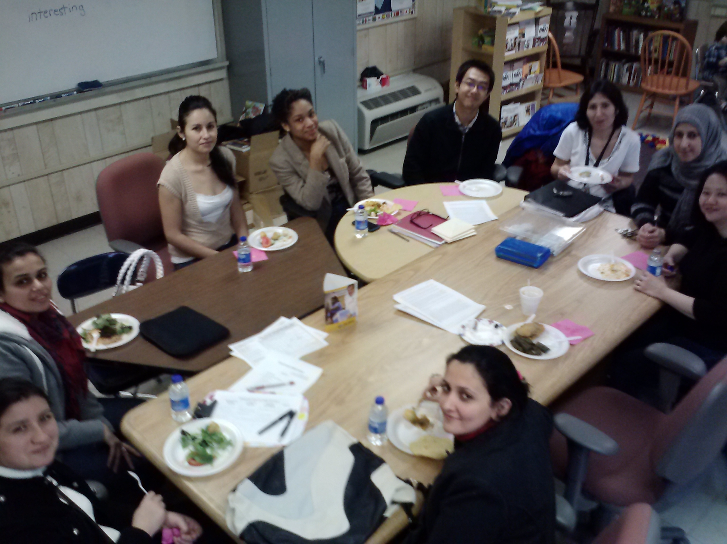Our middle level English class *loves* potlucks!!

Contact: Sarah Carpenter; Portable 17, 333-5179 x150

<http://tusculumfrc.yolasite.com/>; “Like” us on Facebook

Being the Change

Many of you helped collect supplies at the beginning of the year. Thank you! But we’re past the half-way point, and the need is still here.

Will you help our teachers by sending tissues, paper towels, Clorox wipes, glue sticks, and pencils and erasers?

Thank you to:

All of our volunteer tutors and teachers! You’re making a bigger difference than you know!

Our many business and non-profit partners! Your interest in and support of our school is inspiring!

"When schools, families, and community groups work together to support learning,

children tend to do better in school, stay in school longer, and like school more."

~Report from the Southwest Educational Development Laboratory~

Equal Partners

A conversation I frequently have with partners and volunteers is around the symbiotic nature of community development—strengthing our students and their families strengthens our communities; and strengthening our communities, strengthens our students and families. Of course, the opposite is true—if one is weak so is the other.

One of my goals this year has been to give everyone a chance to participate through the Parent Adivsory Council and the Nolensville Road Task Force. I look forward to seeing those grow. Thank you all for your help in making these things successful.

Moving forward, I am interested in your ideas about how we can increase parent involvement in these things and in the school. Our parents *are* the community, and I fear their voices are unheard. What can we do to let them know we want and need their input?

**~Special Report~**

**Coffee and Culture highlighting the Hispanic culture is Thursday March 14th 8:30-10. Spread the word!**