C:\Documents and Settings\scarpenter\Local Settings\Temporary Internet Files\Content.IE5\X9HZ9P5G\MC900058078[1].wmf

Tusculum FRC

Where we are better together

Issue # 17

Coming together is a beginning;

keeping together is progress;

working together is success.  
~[Henry Ford](http://www.brainyquote.com/quotes/authors/h/henry_ford.html)~

Welcome to new PENCIL Partners

* Big Brothers, Big Sisters of Middle TN
* Littler Mendelson
* Tusculum Cumberland Presbyterian Church
* Lipscomb university / SALT
* Nashville International Center for Empowerment (NICE)
* Hillcrest United Methodist Church

If you are not a PENCIL Partner but would like more information about becoming one, let me know!

Being the Change

It’s cold and flu season. Help our teachers by sending tissues, hand sanitizer, and Clorox/Lysol cleaning wipes!

Many classes need field trip sponsors. Let me know if you’re interested in helping!

Nolensville Task Force

We had a wonderful first Partner Meeting. There were about 17 people, representing MNPS, churches, and local non-profits organizations.

After much conversation, we agreed that a Nolensville Task Force is needed. We will begin by meeting in conjuction with the FRC Partner Meetings and will be looking at how we can more effectively work together to address targeted needs. Anyone interested in strengthening this community is welcome to join us!

Minutes from the meeting are available on the FRC webpage.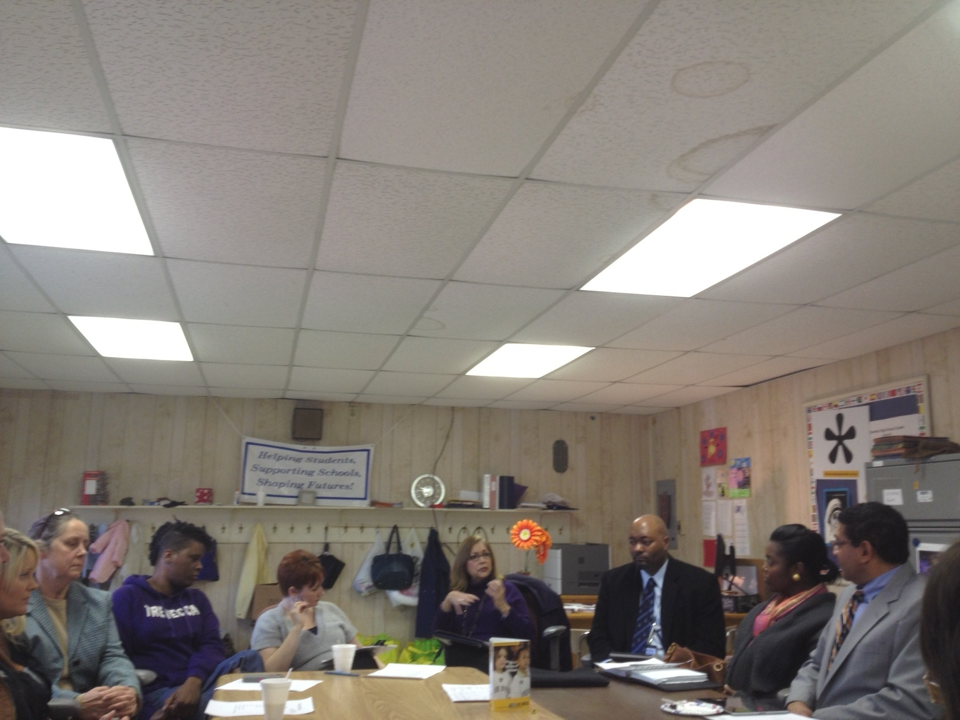

Contact

Sarah Carpenter

Portable 17, 333-5179 x150

<http://tusculumfrc.yolasite.com/>

“Like” us on Face book for pictures

**~Special Report~**

**Our next Parent Advisory Council is March 5th, 6pm, in portable 17. All Tusculum parents and staff are welcome.**

**Coffee and Culture highlighting the Hispanic culture is Thursday March 14th 8:30-10. Spread the word!**