C:\Documents and Settings\scarpenter\Local Settings\Temporary Internet Files\Content.IE5\X9HZ9P5G\MC900058078[1].wmf

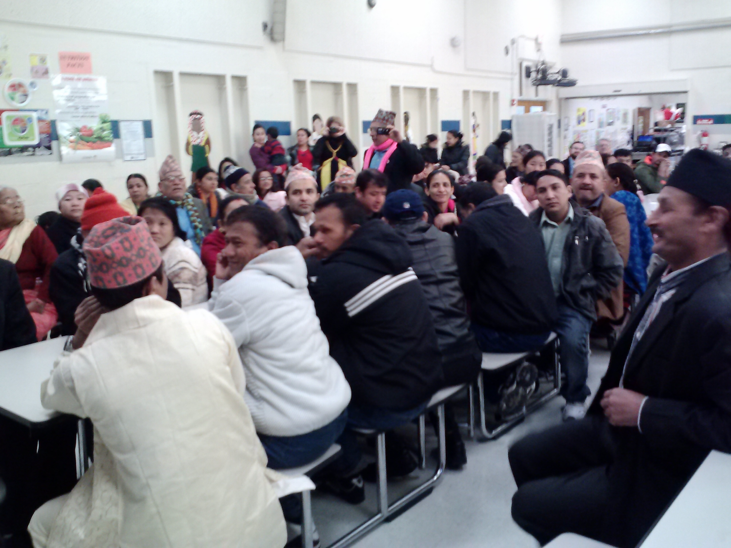

Namaste!

That is a traditional Nepali greeting. Say it as you place your hands together and bow slightly to the other to convey salutations, honor, and respect.

On Valentines day, we celebrated our Nepali population with a Coffee and Culture event. they wore traditional clothing, brought food, laughed at my bad pronunciation of their names, and answered a few of my nosey questions. Sadly, I don’t have time to tell you everything but I want to share two things:

First, our Nepali families are so very friendly and happy to share their lives with us! Don’t be intimidated by them. Be brave, say hi, be friends!

Second, they miss home! They miss celebrating their own holidays. They miss their mountains. They miss belonging. Please be merciful and remember that they don’t get off for their celebrations like we do and they don’t see their childhood homes.

Want to help? Be a friend!

Find more pictures of the event on the FRC Facebook page!

*Uniquely Me*

by Alex Graham James

Third Culture Kid

“I am

a confusion of cultures.

Uniquely me.

I think this is good

because I can

understand

the traveler, sojourner, foreigner,

the homesickness

that comes.

I think this is also bad

because I cannot

be understood by the person who has sown and grown in one place.

They know not

the real meaning of homesickness that hits me

now and then.

Sometimes I despair of understanding them.

I am

an island and

a United Nations. Who can recognize either in me

but God?

Tusculum FRC

Where we are better together

Issue # 16

**~Special Report~**

**The Partner Meeting is February 21st at 9am—have you RSVP’d? Please do so today. Everyone is welcome!**

FRC Director: Sarah Carpenter

Portable 17, 333-5179 x155

<http://tusculumfrc.yolasite.com/>

Please consider having your own life changed by mentoring or tutoring during your free time!

Thank you to:

Everyone who helped with Coffee and Culture. Specifically, Leela Chamlagai for all his hard work planning it and the Whites for providing transportation to many of our guests.