C:\Documents and Settings\scarpenter\Local Settings\Temporary Internet Files\Content.IE5\X9HZ9P5G\MC900058078[1].wmf

Tusculum FRC

Where we are better together

Issue # 14

[I have a dream that my four little children will one day live in a nation where they will not be judged by the color of their skin, but by the content of their character.](http://www.brainyquote.com/quotes/quotes/m/martinluth115056.html)   
~**[Martin Luther King, Jr.](http://www.brainyquote.com/quotes/quotes/m/martinluth115056.html" \o "view quote)**~

What we offer this semester

Beginner, Middle, and Advanced English

Friendship Building Groups

Education on Community Resources

Emergency Supplies

Family and Teacher support

And so much more…

Director’s Corner

The best part of my job is bringing our families together. The other day, I taught a workshop. Each language group sat at separate tables. I said to a friend, “I dream that, one day, they will sit together!”

While I’m no MLK, Jr., I like to think that we’re making a difference here. I like to think that, with time, friendships will be built and barriers removed.

Thanks for joining our experiment!

**~Special Report~**

**Our next Coffee and Culture event is February 14th 8:30-10. We will highlight our Nepali families this time. Mark your calendars and spread the word!**

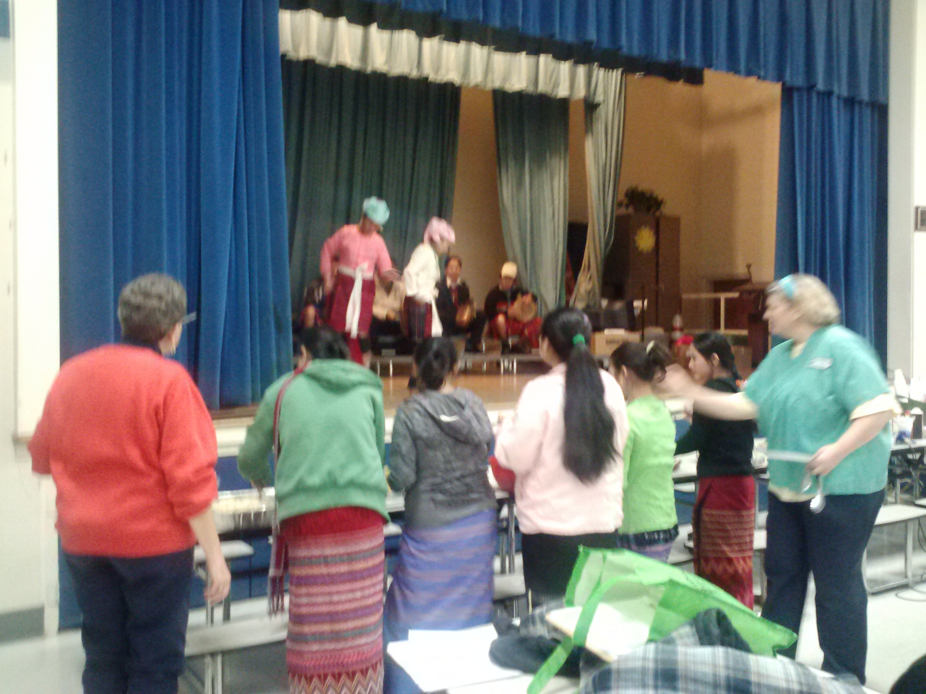We enjoyed traditional Burmese music and dancing. See more pictures on Facebook: <https://www.facebook.com/media/set/?set=a.280212552104453.65321.222957847829924&type=1&l=262bf40e1c>

Finding a Solution

* Teach chess to 3/4th grade.
* Hold a drive with your friends or co-workers.
* Adopt a classroom.
* Invite me to talk in your class, church, staff meeting, social group.

**Mentor/tutor a student during your free time.**

Thank you to:

Our Burmese translator Hkawn Laphai for organizing a wonderful first Coffee and Culture event!

Sarah Carpenter

Portable 17, 333-5179 x150

<http://tusculumfrc.yolasite.com/>