C:\Documents and Settings\scarpenter\Local Settings\Temporary Internet Files\Content.IE5\X9HZ9P5G\MC900058078[1].wmf

Tusculum FRC

Where we are better together

Issue # 13

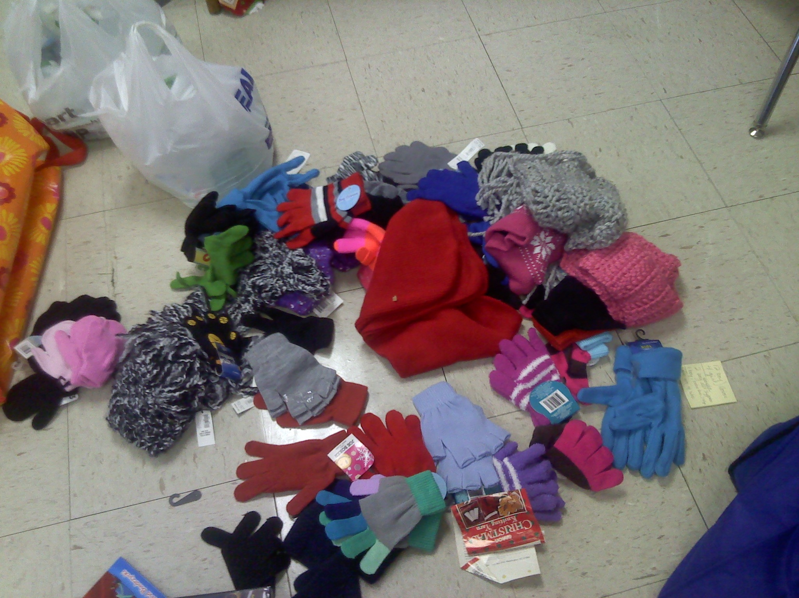

Hillcrest UMC held a glove drive with awesome results.

**More wishes can be found online** [**http://tusculumfrc.yolasite.com/wish-list.php**](http://tusculumfrc.yolasite.com/wish-list.php)

**Finding a Solution**

* Teach 3/4th grade how to play chess.
* Mentor a student or a family once a week/month.
* Hold a cleaning supplies drive—Clorox wipes, paper towels, soap.
* Hold a health supplies drive— Tissues, Band-Aids, Hand Sanitizer
* Hold a treasure box drive—cars, crayons, puzzles, small dolls.
* Pick up something from the wish list every time you’re at the store.
* Adopt a classroom—help meet physical needs, tutor, read to the class, encourage the teacher.
* Invite me to talk in your class, church, staff meeting, social group.

If we could change ourselves, the tendencies in the world would also change. As a man changes his own nature, so does the attitude of the world change towards him... We need not wait to see what others do.

~Gandhi~

Director’s Corner

Sometimes, the level of need overwhelms me. I listen to the news and feel angry and discouraged because the task is bigger than I am.

But here at the FRC, while we do not deny that the problems are huge, we focus on finding solutions. We are not waiting for the world to change, like John Mayer’s song says. We are finding ways to make a difference now.

To that end, today, I’m providing you with a wish list. These are small things that add up to big change.

Thank you to:

Everyone who is taking our work into the community!

Sarah Carpenter

Portable 17, 333-5179 x150

<http://tusculumfrc.yolasite.com/>