C:\Documents and Settings\scarpenter\Local Settings\Temporary Internet Files\Content.IE5\X9HZ9P5G\MC900058078[1].wmf

Tusculum FRC

Where we are better together

Issue # 12

Thank you to:

All the donations of time and resources for the Toys for Tots give out. We served almost 80 parents that day with toys, hot chocolate, and gloves and coats. Left over hot chocolate mix (we had TONS) was given to the Nashville Rescue Mission on Christmas Eve.

Thank you for everything!

You’re amazing!

**What can *you* do?**

* Hold drives with your friends, church, or school for supplies.
* Tutor in the classroom or in a family home.
* Donate your unique skills: fixing cars, taking pictures, grant writing, communications, etc.
* Check the FRC website for Tusculum’s wish list for more ideas!

“You never know when you’re making a memory.”

~Rickie Lee Jones~

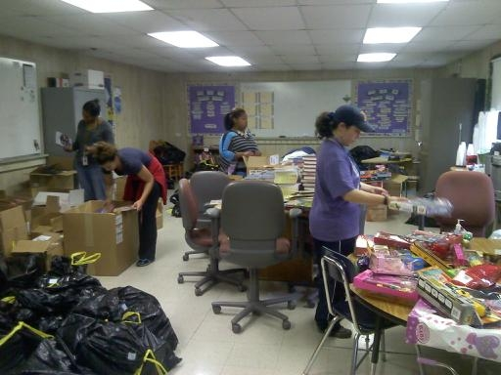

Toys for Tots gave us boxes and boxes of books. Before break, teachers got to choose sets for their classes.

**Watch for…**

* New levels of English classes—Beginner, Middle, and Advanced
* Coffee and culture mornings—this month’s highlights the Burmese culture
* More workshops—finances, parenting, health, and more
* The first Nolensville Task Force meeting in February

Sharing Stories

Pictures and a video from the Partner Celebration are now up on the FRC Facebook page. Check them out when you get time. In just a few months, so much has happened and it’s a joy to see the parents and volunteers share their experiences.

**Special Report**

**The second Parent Advisory Council is January 16th. Are you coming? Do you have a parent who might want to come? Let me know!**

Sarah Carpenter

Portable 17, 333-5179 x150

<http://tusculumfrc.yolasite.com/>