

Tusculum FRC

Where we are better together

Issue # 11—Holiday Edition

Message from your Director

I heard the most beautiful song yesterday; Love is Christmas, by Sara Bareilles:

*I don't care if the carpet's stained We've got food upon our table*

*I don't care if it's gonna rain*

*Our little room is warm and stable   
Love is who we are*

*And no season can contain*

*Love would never fall for that*

Maybe it’s easier for me to wax poetic because I don’t truly know what it’s like to go without. Living life with families here helps put things into perspective. As I remind parents that Christmas doesn’t come from a store, I have to remind myself as well. I have to remember the Spirit of Love and Generosity and Gratitude.

This season, I hope you experience holiday magic and beauty. I don’t think it matters what you believe—there is no greater gift than love.

Thank you to:

Mr. and Mrs. White for all the books. What a nice Christmas gift!

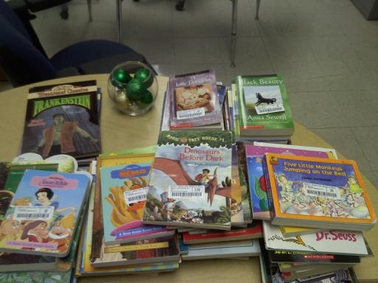

To Carol Roberts for donating a sewing machine to the FRC!

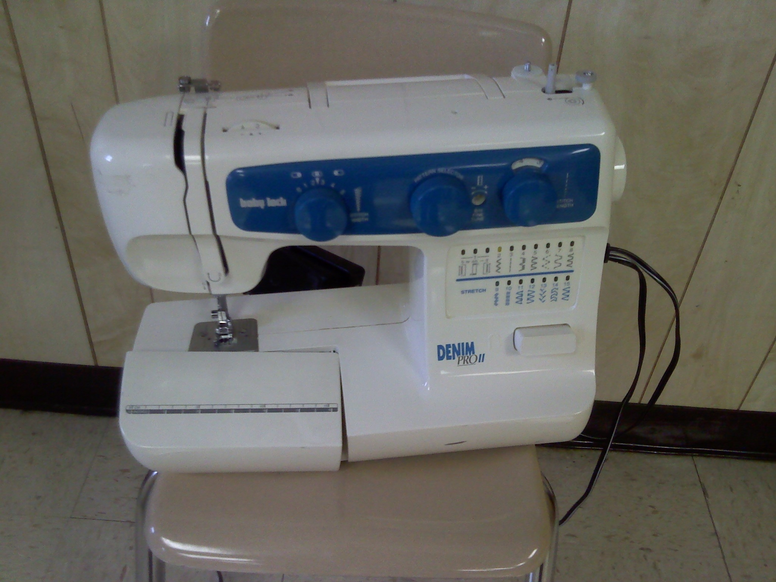

To everyone who helped with the Partner Celebration. You can see a short video from the event at <http://www.youtube.com/watch?v=sKVyIni0pMY&feature=youtu.be>

Specifically, I’d like to say think you to Hillcrest UMC; teachers Mrs. Townsend, Mrs. Coke, Mrs. Holloway, Mrs. Black, Mrs. Knotts, and Mrs. Haley; Photographer Jennifer Pinckney (Eternal Moments Studios); volunteers Bianca Larkin and Shuzhan Li; Parents Tien, Zhara, and Mary; and, of course, Mrs. Hulse!! I couldn’t have done it without you!

Sarah Carpenter

Portable 17, 333-5179 x155

<http://tusculumfrc.yolasite.com/>

“Christmas waves a magic wand over this world, and behold, everything is softer and more beautiful.”

~~ [Norman Vincent Peale](http://www.goodreads.com/author/show/8435.Norman_Vincent_Peale)~~

Next Year’s Plans

* FRC Classes—will continue with basic ESL, middle ESL, and advanced English; crocheting and knitting group; parent conversation; citizenship; and afterschool homework help.
* Coffee and culture starts in January—giving parents a chance to build friendship and share culture.
* Workshops on parenting and budgeting are in the works
* A Nolensville Task Force will be formed—to discuss how we are currently serving south Nashville and how we can better work together. Email me if you are interested in joining the conversation.
* Computer classes—as soon as we get computers. ☺

It’s going to be a very exciting year!

**What can *you* do?**

* We need ESL teachers and classroom tutors for next semester. Please volunteer or refer others.
* My Toys for Tots pick up is December 17th. Can you help me load and unload toys that day?
* Toys for Tots parents pick up is December 22nd, starting at 7am. I need to borrow large coffee urns to keep water warm for hot chocolate. I also need disposable cups, candy canes, and, of course, hot chocolate.
* You can also check the FRC website for Tusculum’s wish list anytime you feel like helping! The list includes things like pencils, books, furniture, volunteers, and more.



**Special Report**

**Enjoy the holidays! Newsletter 12 will come out next year.**

**The FRC is closed December 23-January 1. And will reopen on January 2nd.**

**FRC classes start January 14th.**