C:\Documents and Settings\scarpenter\Local Settings\Temporary Internet Files\Content.IE5\X9HZ9P5G\MC900058078[1].wmf

Tusculum FRC

Where we are better together

Issue # 10

Thank you to:

The White family for all of their help with supplies for the FRC.

Everyone who has volunteered to help with Toys for Tots.

Sharing Stories

Conversation and crochet class have quickly become my favorite events. The past few weeks we have been talking about stereotypes, adjusting to life in the US, and our traditions. It’s truly an enjoyable time!

As a professional, I am always wondering how to quantify what is happening out here. I don’t know how to prove it, but I know we are making a difference out here!

**What can *you* do?**

* I need more ESL tutors for next semester. Please volunteer or refer others.
* My Toys for Tots pick up is December 17th. Can you help me load and unload toys that day?
* Sorting and bagging Toys for Tots gifts is December 19th, 12pm until we are finished. Can you help?
* Toys for Tots parents pick up is December 22nd, starting at 7am. I need to borrow large coffee urns to keep water warm for hot chocolate. I also need disposable cups, candy canes, and, of course, hot chocolate.
* You can also check the FRC website for Tusculum’s wish list anytime you feel like helping!



**Special Report**

**The Partner Celebration is next week. Are you coming?**

“We cannot all do great things, but we can do small things with great love.”

~~Mother Theresa~~

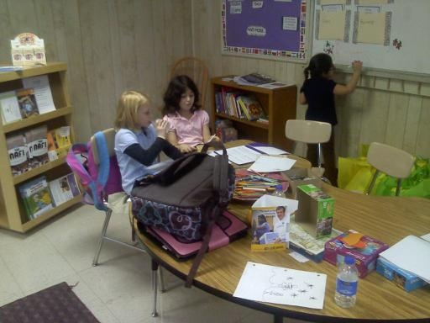

My daughter enjoys studying with other kids during Homework Help.

Sarah Carpenter

Portable 17, 333-5179 x150

<http://tusculumfrc.yolasite.com/>